Graphic 1

New User Experience Existing UDA Experience

* Non-complex evaluations
* Contain basic rules
* “smaller” evaluations
* Clinically complex evaluations
* Require advanced rules
* Disease specific soft required logic
* “larger” evaluations

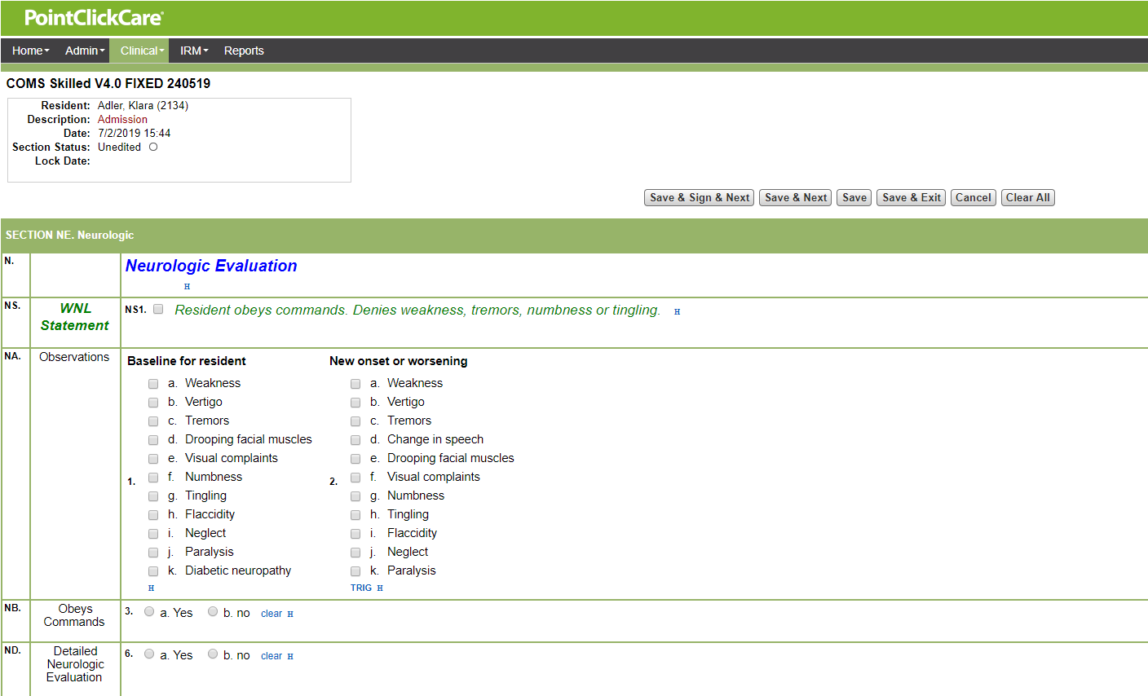

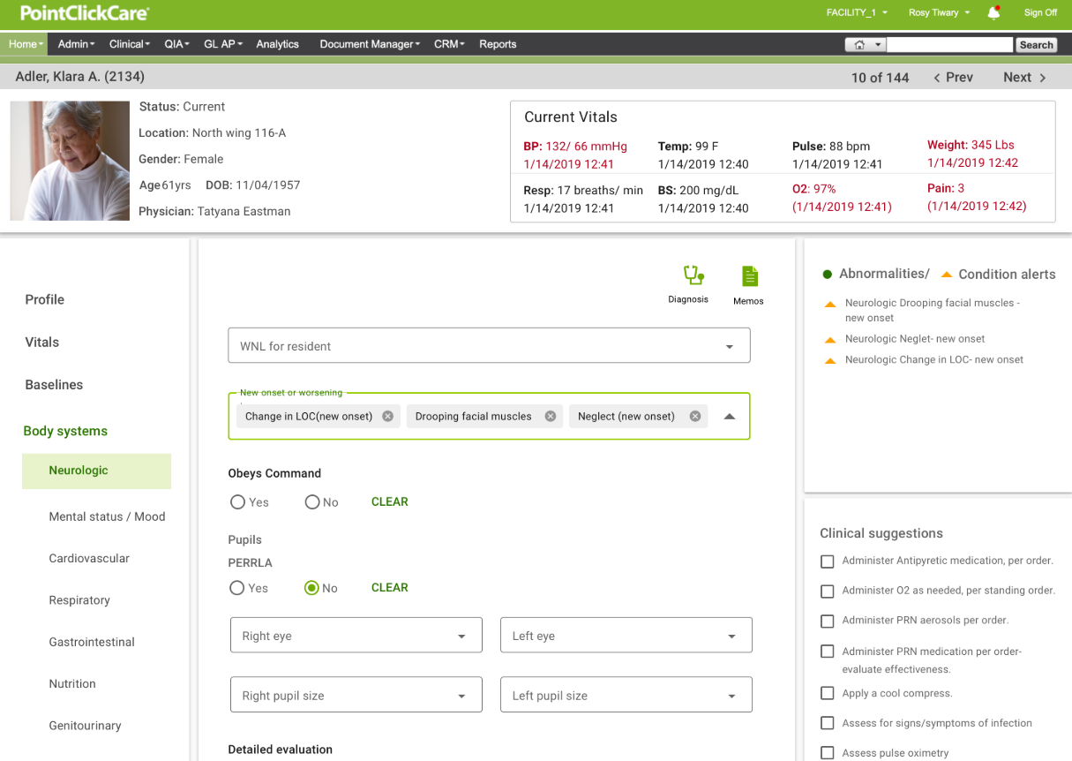

Graphic 2

Existing UDA Experience

SPN

Care Profile

Care Profile

Vital Signs tables

COMS Evaluation

MDS

Vital Signs w/in 60 min. min

Care plan Triggers

High Risk Alerts

Advanced Alerts Engine

Graphic 3

New Evaluation Experience

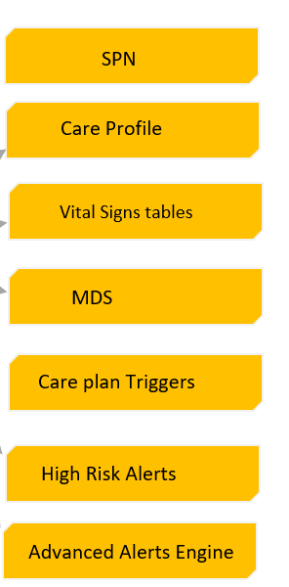

Care Profile

Advanced Clinical Rules Engine

Care Pathway Rule Logic

Care Guide Triggers

Medication Info.

Historical Pain / Skin

COMS Evaluation

Diagnosis

Care Review Memos

Vital Signs w/in 60 min. min